

GRADE 11
JULY EXAMINATIONS 2012
HISTORY
PAPER 2 (ESSAY Paper)
2 hours 150 marks
- INSTRUCTIONS:
- This paper consists of pages
- There are THREE questions
- You are to answer all the questions in the book provided.
- Make sure your answers are correctly numbered and clearly written. Write on both sides of the page.
- Accurate and adequate factual knowledge is essential; equally important in answering the questions is the ability to use relevant information critically.
- Time yourself and do not spend too much time on one question and too little on another.
- You must place the question paper at the back of your answer book.

EXAMINER: MRS J-A MOGG MODERATORS: MRS A LOURENCO
MRS C SAINTANGELO

SECTION A
Discursive Essay Writing
Write an essay showing evidence of analysis, interpretation, explanation and argument.

Question 1

RESISTANCE IN THE 1980s

The United Democratic Front was the only internal movement that provided effective mass resistance against P.W.Botha’s policy of Total Strategy between 1983 and 1989.
Assess the validity of this statement by providing evidence from the period to justify your answer.
70 marks

PLEASE TURN THE PAGE
SECTION B
Extended Writing
In this section BOTH questions are compulsory. Your answers must show evidence of historical knowledge and understanding.

Question 2
VIOLENCE
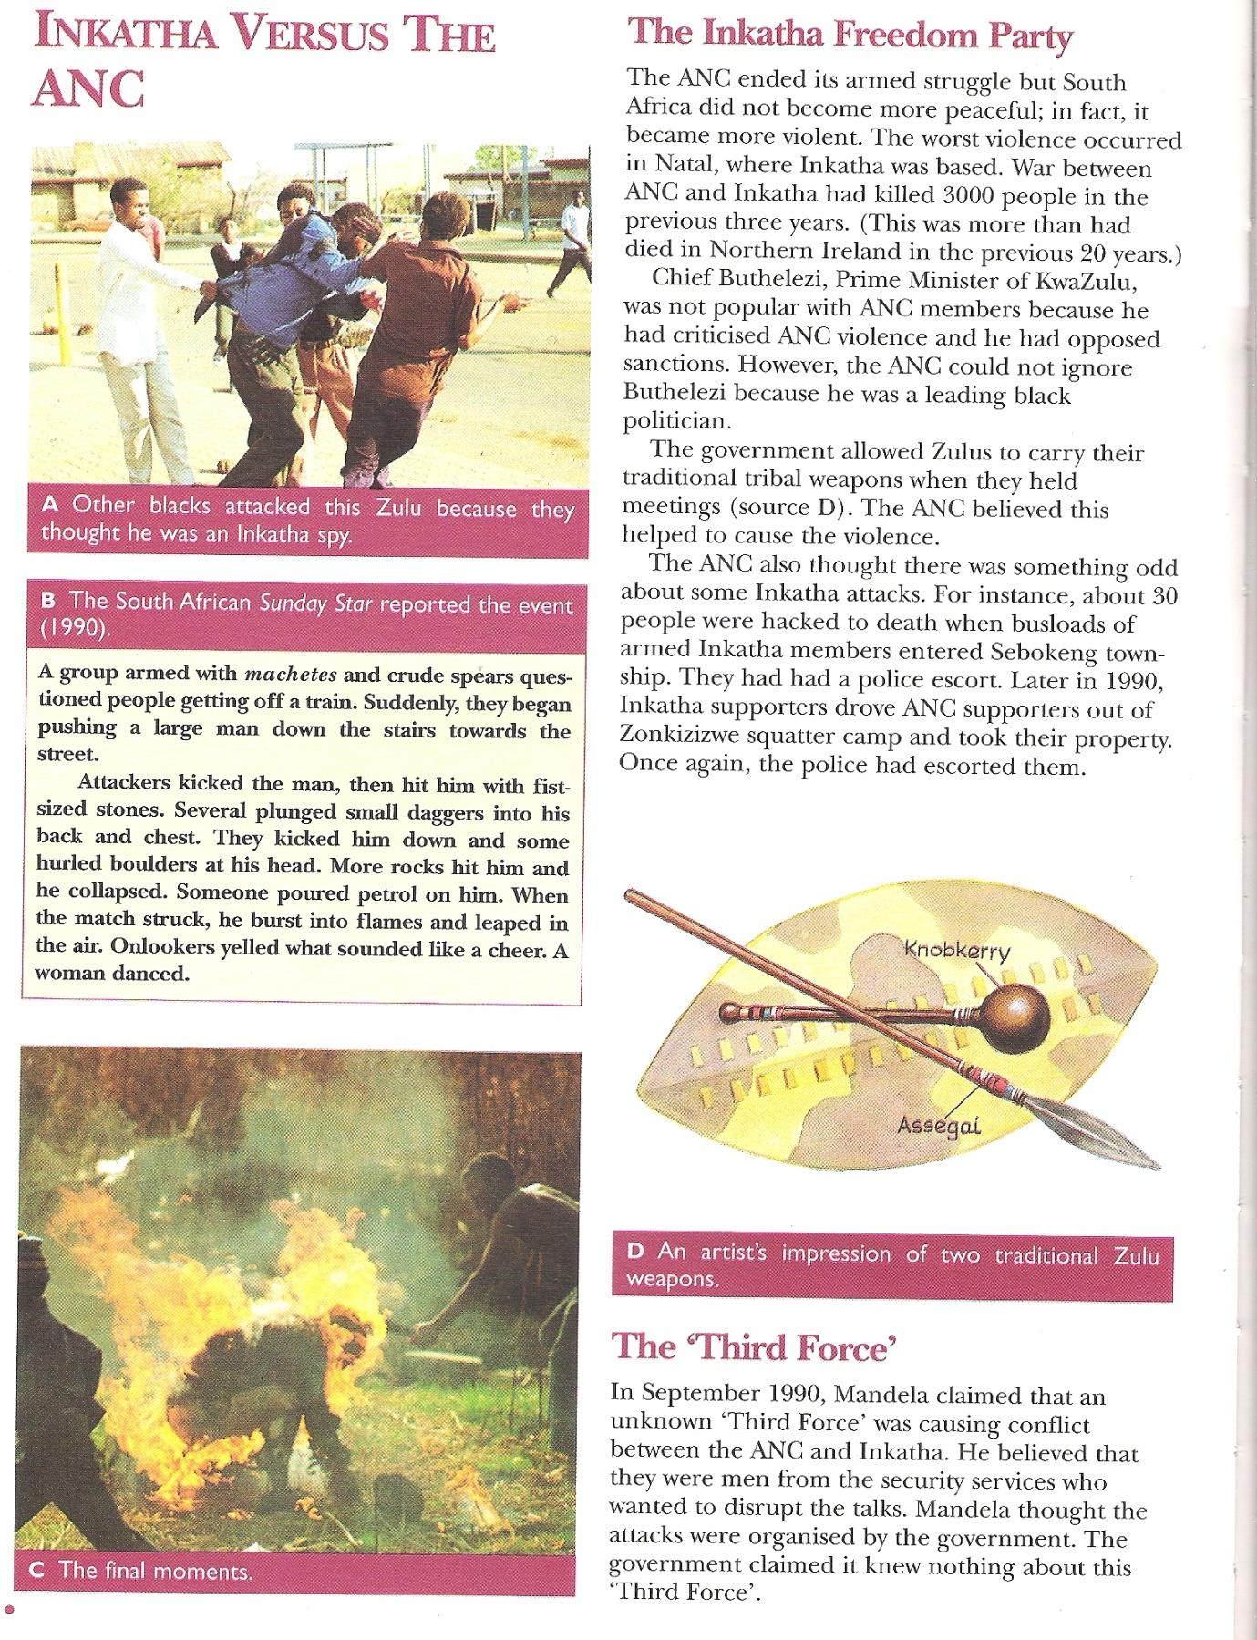
A photograph of black showing black-on-black violence, 1990

What was the impact of violence and conflict on the negotiation process?
Use the following as a guide to help you answer the question above:

- What obstacles did the negotiators face in 1990?

- What evidence was there that a Third Force continued to encourage violence in the early 1990s?

40 marks
PLEASE TURN THE PAGE

Question 3
THE GOVERNMENT OF NATIONAL UNITY
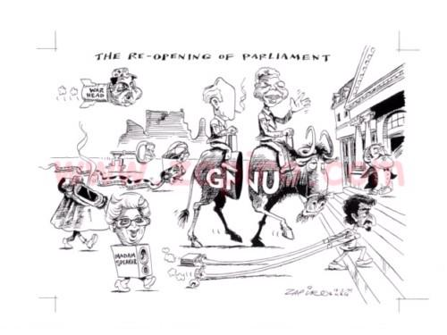
Published in Mail & Guardian on 17 Feb 1995
How was democracy established in South Africa after 1994?
Use the following as a guide to help you answer the above question:
- What was the Government of National Unity?

- What challenges did the GNU face?

- How was the new constitution drawn up and what impact did it have on South Africa?

40 marks

